**Lesson 3: Transformation and Combination of Functions**

After completing this lesson, you should be able to

* discuss vertical and horizontal translations
* discuss vertical and horizontal reflections
* discuss vertical and horizontal stretching and compression
* combine functions
* discuss the composition of functions

**Commentary**

**Topics**

1. [Vertical and Horizontal Translations](https://content.umuc.edu/file/7bdece95-b196-4233-9313-aa904663b08e/1/MATH140-0909.zip/Modules/M1-Module_1/Lesson_3/S3-Commentary.html#I)
2. [Vertical and Horizontal Reflections](https://content.umuc.edu/file/7bdece95-b196-4233-9313-aa904663b08e/1/MATH140-0909.zip/Modules/M1-Module_1/Lesson_3/S3-Commentary.html#II)
3. [Vertical and Horizontal Stretching and Compression](https://content.umuc.edu/file/7bdece95-b196-4233-9313-aa904663b08e/1/MATH140-0909.zip/Modules/M1-Module_1/Lesson_3/S3-Commentary.html#III)
4. [Combining of Functions](https://content.umuc.edu/file/7bdece95-b196-4233-9313-aa904663b08e/1/MATH140-0909.zip/Modules/M1-Module_1/Lesson_3/S3-Commentary.html#IV)
5. [Composition of Functions](https://content.umuc.edu/file/7bdece95-b196-4233-9313-aa904663b08e/1/MATH140-0909.zip/Modules/M1-Module_1/Lesson_3/S3-Commentary.html#V)

In this lesson, we will explore how we can transform or combine some of the more common functions discussed in lesson 2 to construct new functions. By using what we know about the graphs of familiar functions, we can more easily construct the graphs or equations of new functions by hand. In this lesson, we will discuss the more common methods of constructing new functions from familiar ones.

**1. Vertical and Horizontal Translations**

Given *a* > 0,

a **vertical translation** occurs when

* *f*(*x*) + *a* shifts the graph of *f* a distance of *a* units *vertically up*
* *f*(*x*) – *a* shifts the graph of *f* a distance of *a* units *vertically down*

a **horizontal translation** occurs when

* *f*(*x* – *a*) shifts the graph of *f* a distance of *a* units to the *right*
* *f*(*x* + *a*) shifts the graph of *f* a distance of *a* units to the *left*

**Exercise 1.3.1: Graph Vertical Translations**

**Problem**

Given the graph of *f*(*x*) = *x*2, use transformations to find the graphs of *f*(*x*) + 1 and *f*(*x*) – 1 on the same coordinate plane.

**Solution**

* *f*(*x*) + 1 shifts the graph of *f*(*x*) = *x*2 vertically up one unit.
* *f*(*x*) – 1 shifts the graph of *f*(*x*) = *x*2 vertically down one unit.

**Figure 1.3.1  
*f*(*x*) + 1 and *f*(*x*) – 1**

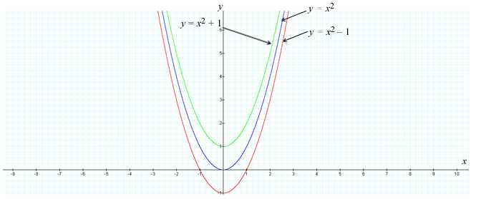

**Exercise 1.3.2: Graph Horizontal Translations**

**Problem**

Given the graph of *f*(*x*) = *x*2, use transformations to find the graph of *g*(*x*) = (*x* + 3)2 and *h*(*x*) = (*x* – 3)2 on the same coordinate plane.

**Solution**

**Figure 1.3.2  
*g*(*x*) = (*x* + 3)2 and *h*(*x*) = (*x* – 3)2**

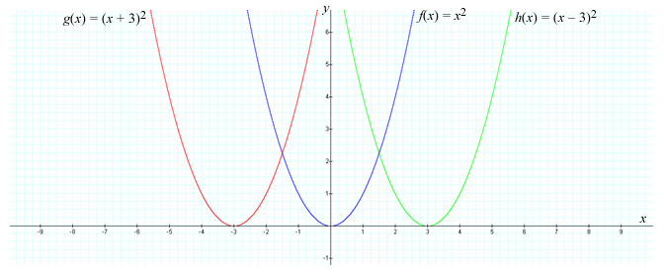

**Exercise 1.3.3: Graph Vertical and Horizontal Translations I**

**Problem**

Given the graph of *f*(*x*) = |*x*|, use transformations to find the graph of *g*(*x*) = |*x* – 3| + 1.

**Solution**

**Figure 1.3.3  
*g*(*x*) = |*x* – 3| + 1**

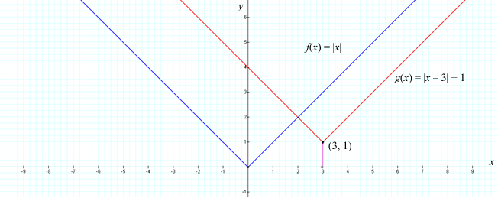

**Exercise 1.3.4: Graph Vertical and Horizontal Translations**

**Problem**

Graph the function *g*(*x*) = *x*2 + 4*x* + 1 using transformations.

**Solution**

We rewrite the equation for the function by completing the square:

*g*(*x*) = *x*2 + 4*x* + 1 = (*x*2 + 4*x* + 4) – 1 = (*x* + 2)2 – 1

Thus, we obtain the desired graph of *g*(*x*) by shifting the graph of *f*(*x*) = *x*2 to the left two units and down one unit.

**Figure 1.3.4  
*g*(*x*) = *x*2 + 4*x* + 1**

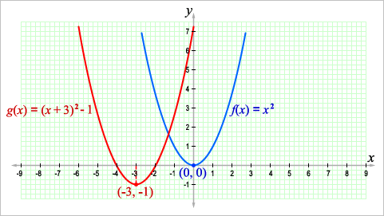

**Exercise 1.3.5: Graph the Vertical and Horizontal Translation of an Exponential Function**

**Problem**

Graph the function *h*(*x*) = 2*x*– 3 + 1 using transformations.

**Solution**

Recall the graph of the function *f*(*x*) = 2*x* in lesson 2, figure 1.2.26. We recreate that graph here:

**Figure 1.3.5  
*f*(*x*) = 2*x***

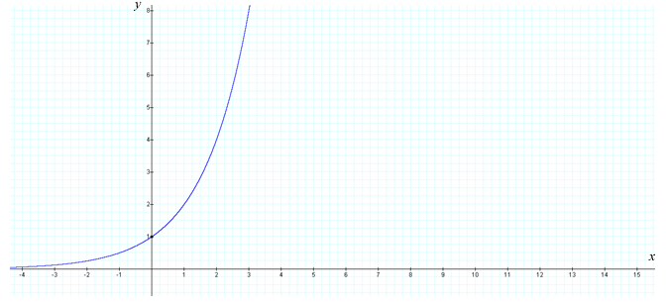

We obtain the graph of *h*(*x*) = 2*x*– 3 + 1 by shifting the graph of *f*(*x*) = 2*x* horizontally three units to the right and vertically one unit up.

**Figure 1.3.6  
*h*(*x*) = 2*x*– 3 + 1**

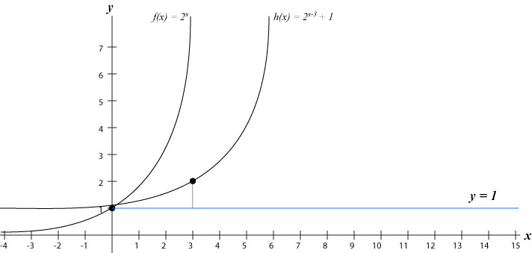

**Note This**

|  |  |
| --- | --- |
| https://content.umuc.edu/file/7bdece95-b196-4233-9313-aa904663b08e/1/MATH140-0909.zip/Modules/M1-Module_1/Lesson_3/images/NoteThisIcon.png | Whenever an exponential function is translated vertically, the horizontal asymptote and the *y*-intercept are translated by the same amount. |

**Exercise 1.3.6: Graph a Vertical and Horizontal Translation of a Logarithmic Function**

**Problem**

Graph the function *h*(*x*) = log2(*x* – 2) + 1 using transformations.

We obtain the graph of *h*(*x*) = log2(*x* – 2) + 1 by shifting the graph of *f*(*x*) = log2*x* horizontally two units to the right and vertically one unit up (see figure 1.3.8).

**Solution**

Recall the graph of the function *f*(*x*) = log2*x* in lesson 2, figure 1.2.28:

**Figure 1.3.7  
*f*(*x*) = log2*x***

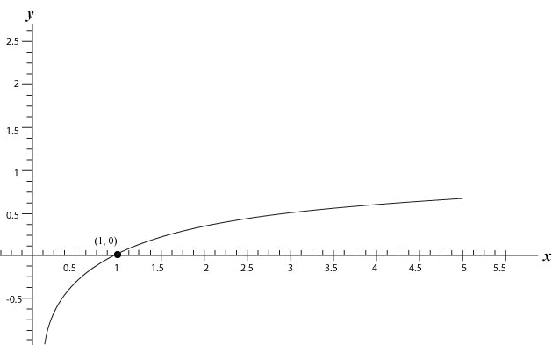

We obtain the graph of *h*(*x*) = log2(*x* – 2) + 1 by shifting the graph of *f*(*x*) = log2*x* horizontally two units to the right and vertically one unit up.

**Figure 1.3.8  
*h*(*x*) = log2(*x* – 2) + 1**

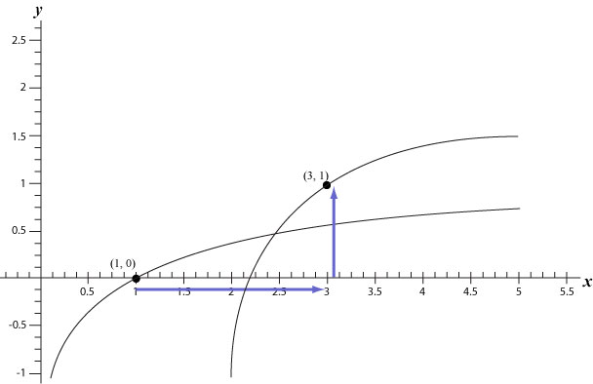

**Note This**

|  |  |
| --- | --- |
| https://content.umuc.edu/file/7bdece95-b196-4233-9313-aa904663b08e/1/MATH140-0909.zip/Modules/M1-Module_1/Lesson_3/images/NoteThisIcon.png | Whenever a logarithmic function is translated horizontally, the vertical asymptote and the *y*-intercept are translated by the same amount. |

**2. Vertical and Horizontal Reflections**

A **vertical reflection** occurs when

* –*f*(*x*) reflects the graph of *f*(*x*) through the *x*-axis

A **horizontal reflection** occurs when

* *f*(–*x*) reflects the graph of *f*(*x*) through the *y*-axis

**Exercise 1.3.7: Graph a Vertical Reflection**

**Problem**

Given the graph of *f*(*x*) = https://content.umuc.edu/file/7bdece95-b196-4233-9313-aa904663b08e/1/MATH140-0909.zip/Modules/M1-Module_1/Lesson_3/images/sqrt-x.gif, use transformations to find the graph of *g*(*x*) = –https://content.umuc.edu/file/7bdece95-b196-4233-9313-aa904663b08e/1/MATH140-0909.zip/Modules/M1-Module_1/Lesson_3/images/sqrt-x.gif on the same coordinate plane.

**Solution**

The graph of *g*(*x*) = –https://content.umuc.edu/file/7bdece95-b196-4233-9313-aa904663b08e/1/MATH140-0909.zip/Modules/M1-Module_1/Lesson_3/images/sqrt-x.gif is a vertical reflection through the *x*-axis.

**https://content.umuc.edu/file/7bdece95-b196-4233-9313-aa904663b08e/1/MATH140-0909.zip/Modules/M1-Module_1/Lesson_3/images/MATH140-fig-1-3-9-fighead.gif**

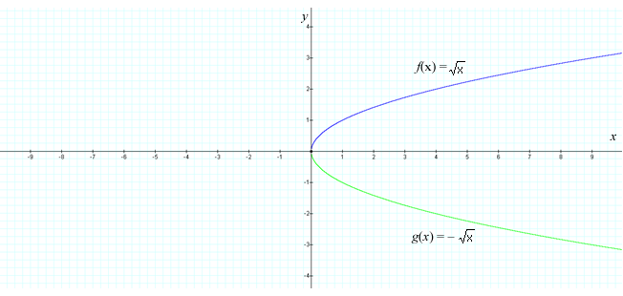

**Exercise 1.3.8: Graph a Horizontal Reflection**

**Problem**

Given the graph of *f*(*x*) = https://content.umuc.edu/file/7bdece95-b196-4233-9313-aa904663b08e/1/MATH140-0909.zip/Modules/M1-Module_1/Lesson_3/images/sqrt-x.gif, use transformations to find the graph of *g*(*x*) = https://content.umuc.edu/file/7bdece95-b196-4233-9313-aa904663b08e/1/MATH140-0909.zip/Modules/M1-Module_1/Lesson_3/images/sqrt--x.gifon the same coordinate plane.

**Solution**

The graph of *g*(*x*) = https://content.umuc.edu/file/7bdece95-b196-4233-9313-aa904663b08e/1/MATH140-0909.zip/Modules/M1-Module_1/Lesson_3/images/sqrt--x.gif is a horizontal reflection through the *y*-axis.

**Note This**

|  |  |
| --- | --- |
| https://content.umuc.edu/file/7bdece95-b196-4233-9313-aa904663b08e/1/MATH140-0909.zip/Modules/M1-Module_1/Lesson_3/images/NoteThisIcon.png | The transformation of the formula and graph also transforms the domain. |

**https://content.umuc.edu/file/7bdece95-b196-4233-9313-aa904663b08e/1/MATH140-0909.zip/Modules/M1-Module_1/Lesson_3/images/MATH140-fig-1-3-10-fighead.gif**

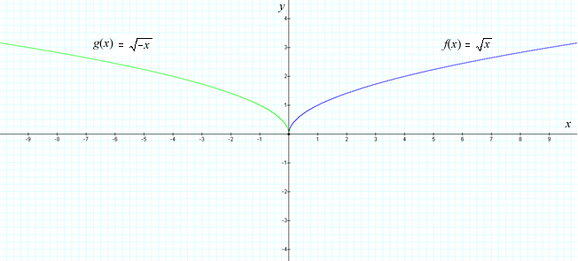

**3. Vertical and Horizontal Stretching and Compression**

Suppose *a* > 1.

A **vertical stretch** occurs when

*af*(*x*) stretches the graph of *f* vertically by a factor of *a*

A **vertical compression** occurs when

(1/*a*)*f*(*x*) compresses the graph of *f* vertically by a factor of *a*

A **horizontal stretch** occurs when

*f*(*x*/*a*) stretches the graph of *f* horizontally by a factor of *a*

A **horizontal compression** occurs when

*f*(*ax*) compresses the graph of *f* horizontally by a factor of *a*

See figures 1.3.11 and 1.3.12:

**https://content.umuc.edu/file/7bdece95-b196-4233-9313-aa904663b08e/1/MATH140-0909.zip/Modules/M1-Module_1/Lesson_3/images/MATH140-lesson3-fig1-3-11-figtitle.gif**

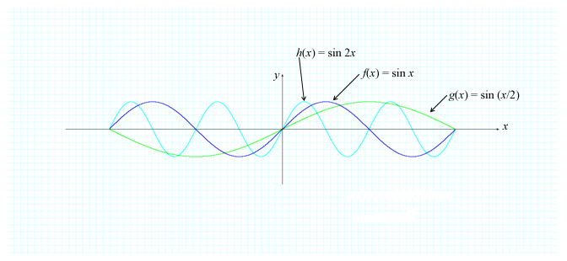

**https://content.umuc.edu/file/7bdece95-b196-4233-9313-aa904663b08e/1/MATH140-0909.zip/Modules/M1-Module_1/Lesson_3/images/MATH140-lesson3-fig1-3-12-figtitle.gif**

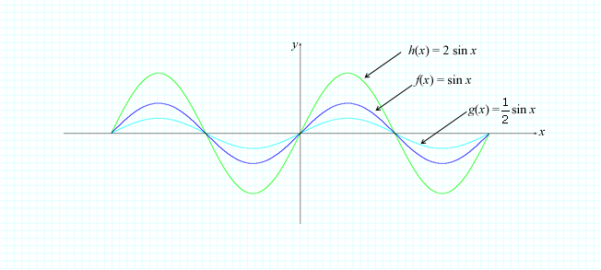

**Exercise 1.3.9: Graph a Transformation of a Trigonometric Function**

**Problem**

Sketch the graph of *g*(*x*) = 3 – cos 2*x* using the appropriate transformations.

**Solution**

We obtain the graph of *g*(*x*) = 3 – cos 2*x* by first vertically compressing the graph of *f*(*x*) = cos *x* by a factor of two, and then reflecting the graph of cos 2*x* through the *x*-axis to obtain the graph of –cos 2*x*. We then vertically translate the graph of –cos 2*x* upward three units to obtain the resulting graph of *g*(*x*) = 3 – cos 2*x*.

**Figure 1.3.13  
*y* = 3 – cos 2*x***

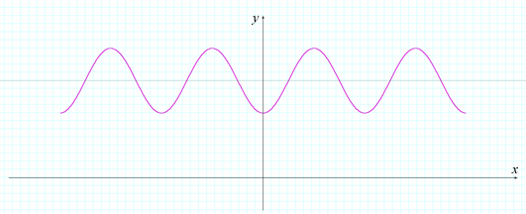

**Exercise 1.3.10: Model Brightness**

A **light curve** is a graph of the observed brightness of an object in space as a function of time. Scientists use light curves to estimate the period of rotation of an object (the amount of time it takes the object to complete a rotation). Figure 1.3.14 shows observation data of an asteroid collected on October 6, 2006 at the Mount John University Observatory at the University of Canterbury in Christchurch, New Zealand (Lawson et al., 1989, 151–155).

The brightness of a variable star, when plotted over time, is periodic. The **magnitude of luminosity** (or *apparent brightness*) of an object in space indicates how bright the object is relative to another object in space. The brighter an object is in space, the more negative is its apparent brightness (our sun has an apparent brightness of –26.73, our moon has an apparent brightness of –12.6 when full, and Pluto has an apparent brightness of 13 at its brightest). The amplitude of the light curve of a celestial object can give us a great deal of information about that object.

**Problem**

Use the scatter plot in figure 1.3.14 to find a function that models the apparent brightness *B* of the asteroid observed at the Mount John University Observatory *t* hours after the observation started.

**Figure 1.3.14  
Asteroid Brightness Scatter Plot**

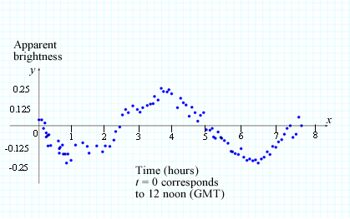

**Solution**

Observe that the scatter plot resembles a shifted and stretched sine function. At *t* = 1, the apparent brightness of the asteroid is approximately –0.25, and at *t* = 4, the apparent brightness is approximately 0.25. The amplitude of the curve (the vertical stretching factor) is

*A* = https://content.umuc.edu/file/7bdece95-b196-4233-9313-aa904663b08e/1/MATH140-0909.zip/Modules/M1-Module_1/Lesson_3/images/1-ovr-2.gif (0. 25 – (–0.25)) = 0.25

The plotted data appear to complete one period, or cycle, in five hours, and the period of cos *x* is 2π; therefore, the horizontal stretching factor is *c* = 2π/5.

Also, notice that this graph is a reflection of sin *t* through the horizontal axis, which makes the coefficient of the sin *t* function negative. Therefore, the apparent brightness *B* of the asteroid *t* hours after the observation began can be modeled by the following function:

*B*(*t*) = –0.25 sin https://content.umuc.edu/file/7bdece95-b196-4233-9313-aa904663b08e/1/MATH140-0909.zip/Modules/M1-Module_1/Lesson_3/images/2pi-ovr-5.gif*t*

**4. Combining of Functions**

Functions *f* and *g* can be combined algebraically just as real numbers can be combined: with the use of the four arithmetic operations—addition, subtraction, multiplication, and division—provided that the denominator is not zero. If we let the sum of two functions *f* and *g* be defined as (*f* + *g*)(*x*) = *f*(*x*) + *g*(*x*), then the sum is well defined as long as *f*(*x*) and *g*(*x*) exist for every *x*. This means that the domain of (*f* + *g*)(*x*) must consist of those values of *x* that belong to the domain of *f* and to the domain of *g*. Another way to state this is that the domain of *f* + *g* must be the intersection of the domains of *f* and *g*.

Similarly, we define *f* + *g*, *f* – *g*, *fg*, and https://content.umuc.edu/file/7bdece95-b196-4233-9313-aa904663b08e/1/MATH140-0909.zip/Modules/M1-Module_1/Lesson_3/images/f-ovr-g1.gif.

Algebra of Functions

Let *f* and *g* be two functions with domains *A* and *B*, respectively. The **sum** *f* + *g*, **difference** *f* – *g*, **product** *fg*, and **quotient** https://content.umuc.edu/file/7bdece95-b196-4233-9313-aa904663b08e/1/MATH140-0909.zip/Modules/M1-Module_1/Lesson_3/images/f-ovr-g1.gif are defined as follows:

|  |  |
| --- | --- |
| (*f* + *g*)(*x*) = *f*(*x*) + *g*(*x*) (*f* – *g*)(*x*) = *f*(*x*) – *g*(*x*) (*fg*)(*x*) = *f*(*x*)*g*(*x*)  https://content.umuc.edu/file/7bdece95-b196-4233-9313-aa904663b08e/1/MATH140-0909.zip/Modules/M1-Module_1/Lesson_3/images/f-ovr-g.gif(*x*) = https://content.umuc.edu/file/7bdece95-b196-4233-9313-aa904663b08e/1/MATH140-0909.zip/Modules/M1-Module_1/Lesson_3/images/fx-ovr-gx.gif | domain = *A* ∩ *B* domain = *A* ∩ *B* domain = *A* ∩ *B* domain = *A* ∩ *B*, provided *g*(*x*) ≠ 0 |

**Note This**

|  |  |
| --- | --- |
| https://content.umuc.edu/file/7bdece95-b196-4233-9313-aa904663b08e/1/MATH140-0909.zip/Modules/M1-Module_1/Lesson_3/images/NoteThisIcon.png | The operation on the left side of the equation represents an operation between two functions, and the operation on the right side of the equation represents an operation between two real numbers. For example, the "+" on the left side of the first equation, (*f* + *g*)(*x*), represents the addition of two functions, *f* and *g*; whereas the "+" on the right side of the first equation, *f*(*x*) + *g*(*x*), represents the addition of two real numbers, *f*(*x*) and *g*(*x*). |

**Exercise 1.3.11: Combine Functions and Determine the Domain**

Suppose https://content.umuc.edu/file/7bdece95-b196-4233-9313-aa904663b08e/1/MATH140-0909.zip/Modules/M1-Module_1/Lesson_3/images/sqrt-9-x-sqrd.gifand .

**Problem**

Find each of the following functions and give their domains:

1. *f* + *g*
2. *f* – *g*
3. *fg*
4. https://content.umuc.edu/file/7bdece95-b196-4233-9313-aa904663b08e/1/MATH140-0909.zip/Modules/M1-Module_1/Lesson_3/images/f-ovr-g1.gif

**Solution**

The domain of https://content.umuc.edu/file/7bdece95-b196-4233-9313-aa904663b08e/1/MATH140-0909.zip/Modules/M1-Module_1/Lesson_3/images/sqrt-9-x-sqrd.gif is all *x*, such that 9 – *x*2 ≥ 0; that is, *x*2 ≤ 9. Taking the square root of both sides of the inequality gives us |*x*| ≤ 3 or –3 ≤ *x* ≤ 3. The domain of *f*(*x*) is {*x* | –3 ≤ *x* ≤ 3} or [–3, 3].

The domain of  is all *x*, such that 3 + *x* ≥ 0; that is, *x* ≥ –3. The domain of *g*(*x*) is {*x* | *x* ≥ –3} or [–3, ∞).

The intersection of the domain of *f* and the domain of *g* is

[–3, 3] ∩ [–3, ∞) = [–3, 3]

Consider the new functions:

1. (*f* + *g*)(*x*) = https://content.umuc.edu/file/7bdece95-b196-4233-9313-aa904663b08e/1/MATH140-0909.zip/Modules/M1-Module_1/Lesson_3/images/-sqrt-9-x-sqrd.gif+ , with domain [–3, 3]
2. (*f* – *g*)(*x*) = https://content.umuc.edu/file/7bdece95-b196-4233-9313-aa904663b08e/1/MATH140-0909.zip/Modules/M1-Module_1/Lesson_3/images/-sqrt-9-x-sqrd.gif– , with domain [–3, 3]
3. (*fg*)(*x*) = https://content.umuc.edu/file/7bdece95-b196-4233-9313-aa904663b08e/1/MATH140-0909.zip/Modules/M1-Module_1/Lesson_3/images/-sqrt-9-x-sqrd.gif= https://content.umuc.edu/file/7bdece95-b196-4233-9313-aa904663b08e/1/MATH140-0909.zip/Modules/M1-Module_1/Lesson_3/images/2-sqrt-eq.gif , with domain [–3, 3]
4. https://content.umuc.edu/file/7bdece95-b196-4233-9313-aa904663b08e/1/MATH140-0909.zip/Modules/M1-Module_1/Lesson_3/images/f-ovr-g.gif(*x*) https://content.umuc.edu/file/7bdece95-b196-4233-9313-aa904663b08e/1/MATH140-0909.zip/Modules/M1-Module_1/Lesson_3/images/2-sqrt-eq1.gif, with domain (–3, 3]

**Note This**

|  |  |
| --- | --- |
| https://content.umuc.edu/file/7bdece95-b196-4233-9313-aa904663b08e/1/MATH140-0909.zip/Modules/M1-Module_1/Lesson_3/images/NoteThisIcon.png | We exclude the endpoint –3, as that would make the denominator zero; *g*(–3) = 0. |

The following figures illustrate graphical operations (addition, subtraction, multiplication, and division).

**Figure 1.3.15  
Graphical Addition**

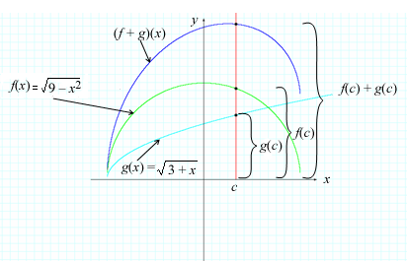

**Figure 1.3.16  
Graphical Subtraction**

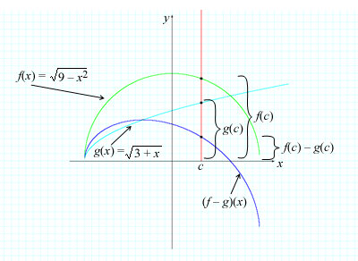

**Figure 1.3.17  
Graphical Multiplication**

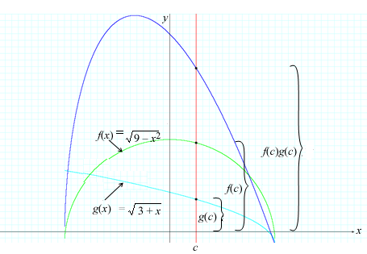

**Figure 1.3.18  
Graphical Division**

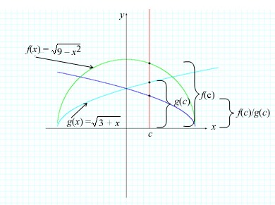

**5. Composition of Functions**

Composition of Functions

Supposing *f* and *g* are functions, the **composite function** *f* ◦ *g* (read "*f* composed with *g*") is defined by

(*f* ◦ *g*)(*x*) = *f*(*g*(*x*))

**Note This**

|  |  |
| --- | --- |
| https://content.umuc.edu/file/7bdece95-b196-4233-9313-aa904663b08e/1/MATH140-0909.zip/Modules/M1-Module_1/Lesson_3/images/NoteThisIcon.png | The domain of the composite function *f* ◦ *g* is the set of all *x* in the domain of *g*(*x*), such that *g*(*x*) is in the domain of *f*. In other words, (*f* ◦ *g*)(*x*) is defined whenever both *g*(*x*) and *f*(*g*(*x*)) are defined. |

**Exercise 1.3.12: Evaluate a Composite Function**

**Problem**

Evaluate (*f* ◦ *g*)(*x*) = *f*(*g*(*x*)). First find *g*(*x*), and then find *f*(*g*(*x*)).

**Solution**

We can visualize *f* ◦ *g* using a machine diagram (see figure 1.3.19a) or using an arrow diagram (see 1.3.19b).

**Figure 1.3.19a  
*f* ◦ *g* Machine Diagram**

**https://content.umuc.edu/file/7bdece95-b196-4233-9313-aa904663b08e/1/MATH140-0909.zip/Modules/M1-Module_1/Lesson_3/images/MATH140-fig-1-3-19a.png**

To evaluate (*f* ◦ *g*)(*x*), we first find *g*(*x*), and then we find *f*(*g*(*x*)).

**Figure 1.3.19b  
*f* ◦ *g* Arrow Diagram**

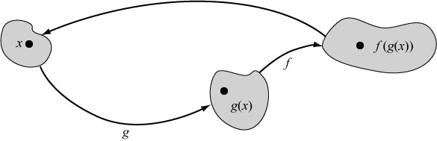

The function *g* maps *x* to *g*(*x*), and then the function *f* maps *g*(*x*) to *f*(*g*(*x*)).

Composition of functions can be used to construct more complex functions from simpler ones, as in Exercises 1.3.12, 1.3.13, and 1.3.14, or to deconstruct complex functions into simpler functions, as in Exercise 1.3.15.

**Exercise 1.3.13: Find the Composite Function**

**Problem**

Given *f*(*x*) = *x* – 1 and *g*(*x*) = https://content.umuc.edu/file/7bdece95-b196-4233-9313-aa904663b08e/1/MATH140-0909.zip/Modules/M1-Module_1/Lesson_3/images/sqrt-x.gif, find *f* ◦ *g* and *g* ◦ *f*.

**Solution**

* (*f ◦ g*)(*x*) = *f*(*g*(*x*)) = *f*(https://content.umuc.edu/file/7bdece95-b196-4233-9313-aa904663b08e/1/MATH140-0909.zip/Modules/M1-Module_1/Lesson_3/images/sqrt-x.gif) = https://content.umuc.edu/file/7bdece95-b196-4233-9313-aa904663b08e/1/MATH140-0909.zip/Modules/M1-Module_1/Lesson_3/images/sqrt-x.gif– 1
* (*g ◦ f*)(*x*) = *g*(*f*(*x*)) = *g*(*x* + 1) = https://content.umuc.edu/file/7bdece95-b196-4233-9313-aa904663b08e/1/MATH140-0909.zip/Modules/M1-Module_1/Lesson_3/images/sqrt-x-1-eq.gif

**Note This**

|  |  |
| --- | --- |
| https://content.umuc.edu/file/7bdece95-b196-4233-9313-aa904663b08e/1/MATH140-0909.zip/Modules/M1-Module_1/Lesson_3/images/NoteThisIcon.png | In general, *f ◦ g* ≠ *g ◦ f*; however, there are special cases in which they are equal. |

**Exercise 1.3.14: Find More Composite Functions**

**Problem**

Given *f*(*x*) = *x*2 and *g*(*x*) = https://content.umuc.edu/file/7bdece95-b196-4233-9313-aa904663b08e/1/MATH140-0909.zip/Modules/M1-Module_1/Lesson_3/images/-sqrt-9-x-sqrd.gif, find each of the following composite functions and the domain of each function.

1. *f ◦ g*
2. *g ◦ f*
3. *f ◦ f*
4. *g ◦ g*

**Solution**

1. (*f ◦ g*)(*x*) = *f*(*g*(*x*)) = *f*(https://content.umuc.edu/file/7bdece95-b196-4233-9313-aa904663b08e/1/MATH140-0909.zip/Modules/M1-Module_1/Lesson_3/images/sqrt9-x.gif) = (https://content.umuc.edu/file/7bdece95-b196-4233-9313-aa904663b08e/1/MATH140-0909.zip/Modules/M1-Module_1/Lesson_3/images/sqrt9-x.gif)2 = 9 – *x*

The domain of *f ◦ g* is all real numbers, or (– ∞, ∞), as 9 – *x* is defined for any value of *x*.

1. (*g ◦ f*)(*x*) = *g*(*f*(*x*)) = *g*(*x*2) =https://content.umuc.edu/file/7bdece95-b196-4233-9313-aa904663b08e/1/MATH140-0909.zip/Modules/M1-Module_1/Lesson_3/images/2-sqrt-eq2.gif

The expression https://content.umuc.edu/file/7bdece95-b196-4233-9313-aa904663b08e/1/MATH140-0909.zip/Modules/M1-Module_1/Lesson_3/images/-sqrt-9-x-sqrd.gifis defined whenever 9 – *x*2 ≥ 0, or *x*2 ≤ 9, and so –3 ≤ *x* ≤ 3. Therefore, the domain of *g ◦ f* is –3 ≥*x* ≤ 3, or the interval [–3, 3].

1. (*f ◦ f*)(*x*) = *f*(*f*(*x*)) = *f*(*x*2) = (*x*2)2 = *x*4

The domain of *f ◦ f* is all real numbers, or (– ∞, ∞).

1. (*g ◦ g*)(*x*) = *g*(*g*(*x*)) = https://content.umuc.edu/file/7bdece95-b196-4233-9313-aa904663b08e/1/MATH140-0909.zip/Modules/M1-Module_1/Lesson_3/images/MATH140-fig-1-3-14d-soltn.gif

The expression https://content.umuc.edu/file/7bdece95-b196-4233-9313-aa904663b08e/1/MATH140-0909.zip/Modules/M1-Module_1/Lesson_3/images/2-sqrt-eq4.gif is defined whenever 9 – https://content.umuc.edu/file/7bdece95-b196-4233-9313-aa904663b08e/1/MATH140-0909.zip/Modules/M1-Module_1/Lesson_3/images/sqrt9-x.gif ≥ 0, or https://content.umuc.edu/file/7bdece95-b196-4233-9313-aa904663b08e/1/MATH140-0909.zip/Modules/M1-Module_1/Lesson_3/images/sqrt9-x.gif≤ 9, or 9 – *x* ≤ 81; that is, whenever *x* ≥ –72.

Also, the expression https://content.umuc.edu/file/7bdece95-b196-4233-9313-aa904663b08e/1/MATH140-0909.zip/Modules/M1-Module_1/Lesson_3/images/sqrt9-x.gif is defined whenever 9 – *x*≥ 0, or *x* ≤ 9. Putting the two inequalities together, we find that the domain of *g ◦ g* is –72 ≤ *x* ≤ 9, or the interval [–72, 9].

**Exercise 1.3.15: Compose Three Functions**

**Problem**

Suppose *f*(*x*) = https://content.umuc.edu/file/7bdece95-b196-4233-9313-aa904663b08e/1/MATH140-0909.zip/Modules/M1-Module_1/Lesson_3/images/1-ovr-1-x.gif, *g*(*x*) = *x*4, and *h*(*x*) = https://content.umuc.edu/file/7bdece95-b196-4233-9313-aa904663b08e/1/MATH140-0909.zip/Modules/M1-Module_1/Lesson_3/images/sqrt-x.gif. Find *f ◦ g ◦ h*.

**Solution**

(*f ◦ g ◦ h*)(*x*) = *f*(*g*(*h*(*x*))) = *f*(*g*(https://content.umuc.edu/file/7bdece95-b196-4233-9313-aa904663b08e/1/MATH140-0909.zip/Modules/M1-Module_1/Lesson_3/images/sqrt-x.gif))

= *f*((https://content.umuc.edu/file/7bdece95-b196-4233-9313-aa904663b08e/1/MATH140-0909.zip/Modules/M1-Module_1/Lesson_3/images/sqrt-x.gif)4)

= *f*(*x*2)

= https://content.umuc.edu/file/7bdece95-b196-4233-9313-aa904663b08e/1/MATH140-0909.zip/Modules/M1-Module_1/Lesson_3/images/1-ovr-1-x2.gif

**Exercise 1.3.16: Use Composition to Decompose a Function**

**Problem**

Find *f*, *g*, and *h* such that (*f ◦ g ◦ h*)(*x*) = .

**Solution**

The formula  suggests that we add 3, apply the square root of the result, and then take the reciprocal, as in these steps:

1. *h*(*x*) = *x* + 3
2. *g*(*x*) = ln *x*
3. *f*(*x*) = https://content.umuc.edu/file/7bdece95-b196-4233-9313-aa904663b08e/1/MATH140-0909.zip/Modules/M1-Module_1/Lesson_3/images/1-ovr-x.gif

Thus,

(*f ◦ g ◦ h*)(*x*) = *f*(*g*(*h*(*x*))) = *f*(*g*(*x* + 3)) = *f*(ln(*x* + 3))

=

**References**

Lawson, W. A., Cottrell, P. L., Gilmore, A. C., & Kilmartin, P. M. (1989). The reclassification of the suspected R Coronae Borealis star SY Hyi as a semiregular variable. *Journal of Astrophysics and Astronomy*, 10, 151–155.

[*Return to top of page*](https://content.umuc.edu/file/7bdece95-b196-4233-9313-aa904663b08e/1/MATH140-0909.zip/Modules/M1-Module_1/Lesson_3/S3-Commentary.html#pagetop)

[**Report broken links or any other problems on this page.**](http://help.umuc.edu/)  
  
[**Copyright © by University of Maryland University College.**](https://content.umuc.edu/file/7bdece95-b196-4233-9313-aa904663b08e/1/MATH140-0909.zip/common/copyright.html)